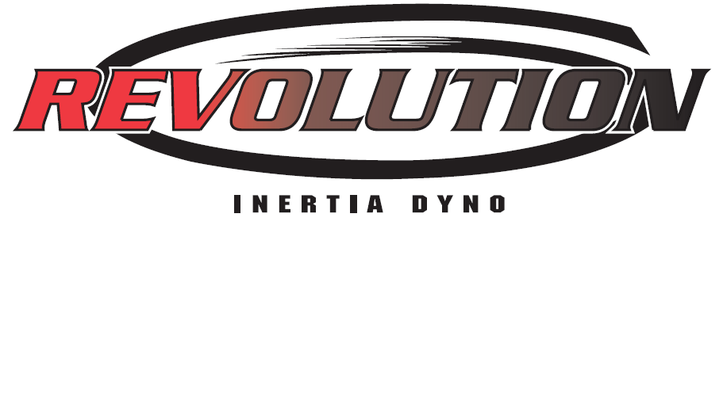
The Revolution Inertia Engine Dynamometer, developed by Excelleration, LLC, provides engine builders and engine component manufacturers with a tool that provides data that directly correlates to on-track engine performance. Using the concept of inertia, the engine is allowed to accelerate at its natural rate. Then, the data is compared in terms of elapsed time when differentiating performance characteristics.
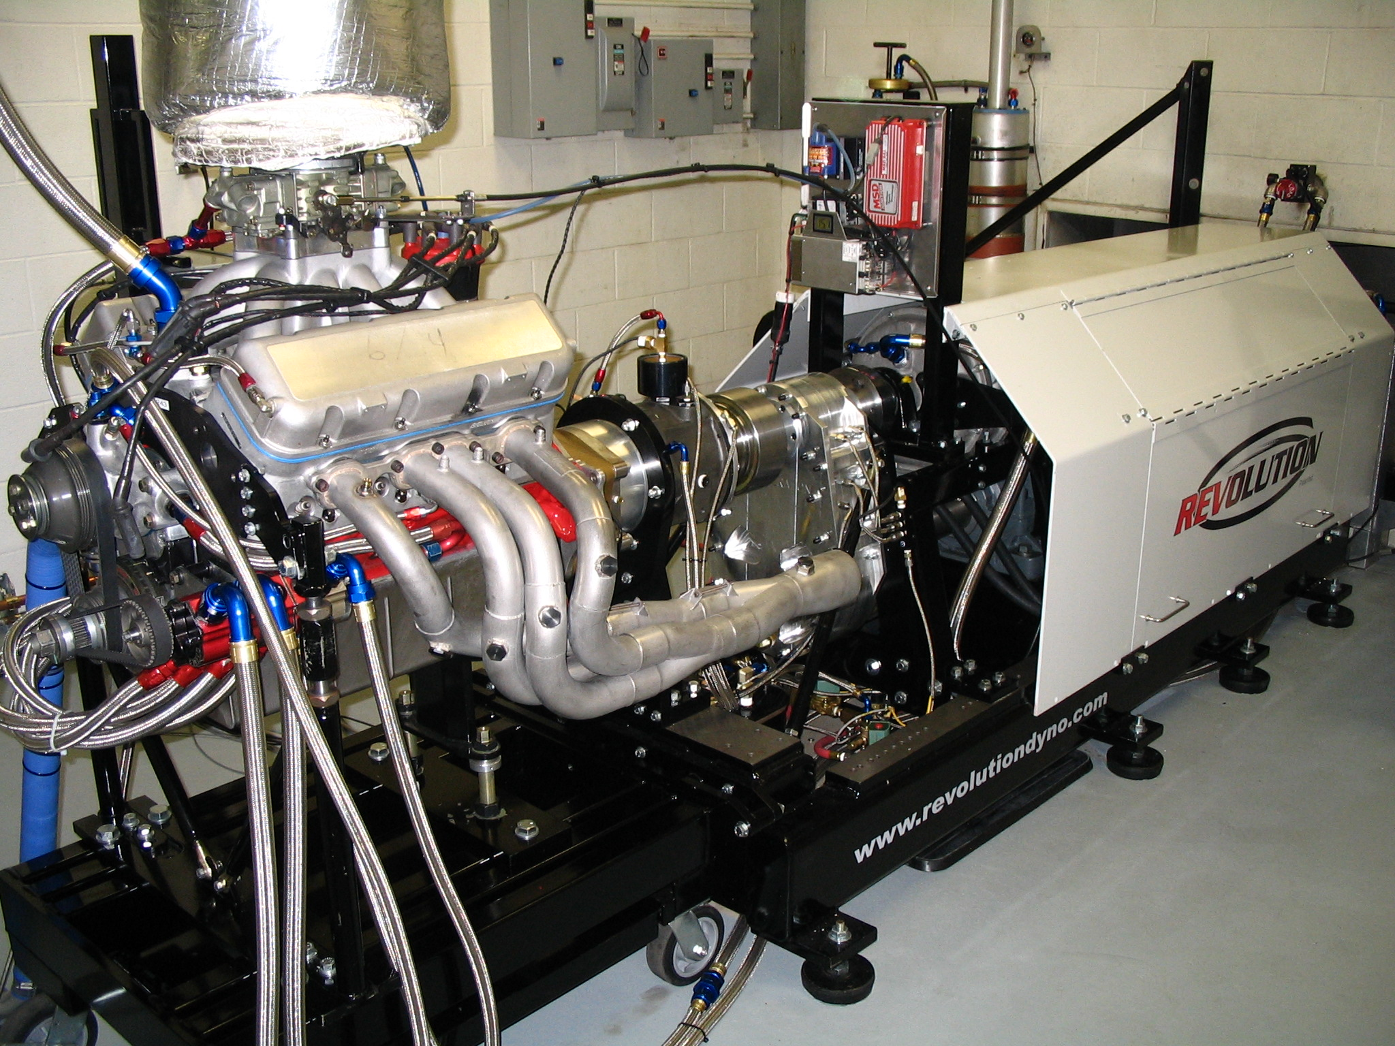

- Adjustable Inertia Configuration for Representing a Variety of Vehicles
- Changeable Gear Ratios for Adjusting the Effective Inertia Representation on the Engine
- High-Torque Engine Testing with Combined Inertia and Absorber Loading Capability
- Dynamometer Clutch Controls Low-Load Inertia Engagement and Rapid Disengagement
- Self-contained Dyno Lubricating System with Temperature Control
- Natural Acceleration Rate Measurements... NEITHER FORCED NOR FIXED
- Elapsed Time Repeatability Measured and Displayed to 0.001 seconds
- Small Magnitude Performance Enhancements are Measurable
- Repeatability within 0.10% of total elapsed time between consecutive sweeps

- Inertia Drives the Engine During Deceleration, as seen on-track
- Direct Coupling Methods – Not Reliant on a Viscous Coupling Technique
- Ability to Test Clockwise and Counter-clockwise Rotation Engines
- The Engine Controls the Dyno... The Dyno Does NOT Control the Engine...

“What Happens… Gets Measured!”

Because of the unique patented design of The Revolution Inertia Dynamometer, the vehicle mass that the engine will accelerate during racing conditions is represented by configuring the inertia and dynamometer gear ratio. The advantage of this feature is a close approximation of the load that the engine experiences during actual racing conditions. Therefore, an engine that performs well on the inertia dynamometer should perform well on the racetrack.
- Vehicles weighing from approximately 1,200 lb up to 3,500 lb (depending on the tire size and the gear ratio of the vehicle) can be represented on one machine.
- Gear Ratios from 3:1 through 5:1 Available for Effective Inertia Configuration
The following table compares a few features of the two most popular classes of dynamometers to The Revolution Inertia Dynamometer.

Dynamometer Type | Coupling Method | Loading Characteristic | Display of Results | Operating Quadrants
Hydraulic/Absorber Dynamometers | Viscous | Dyno Controls Engine | Torque and Power | Absorb Torque some clockwise and anti-clockwise
Electrical Dynamometers | EMF | Dyno Controls Engine | Torque and Power | Absorb Torque, Develop Torque, both directions
The Revolution Inertia Dynamometer | Direct | Engine Controls Dyno | Elapsed Time, Acceleration Rate, Torque and Power | Absorb Torque, Develop Torque (of Vehicle Mass), both directions

- 5252 High Performance Dyno Data Acquisition System Designed for Acceleration Rate Testing, Endurance Testing, and Performance Testing
  - Automated Throttle System Following Pre-recorded Lap Throttle Trace
  - Complete Lap Simulation Using Inertia and Absorber Combined
- Comprehensive Engine Analysis Tools Built-in
- Instantaneous Elapsed Time Results Upon Sweep Completion
- Custom Configurable Graphing and Tabular Results
- Continuously Updated Peak and Average Data Throughout Sweep
- Automated Deceleration System, Using Computer Controlled Absorber
- Unlimited Expansion of Channel Availability
- Event-only Sampling (non-fixed sampling rates)

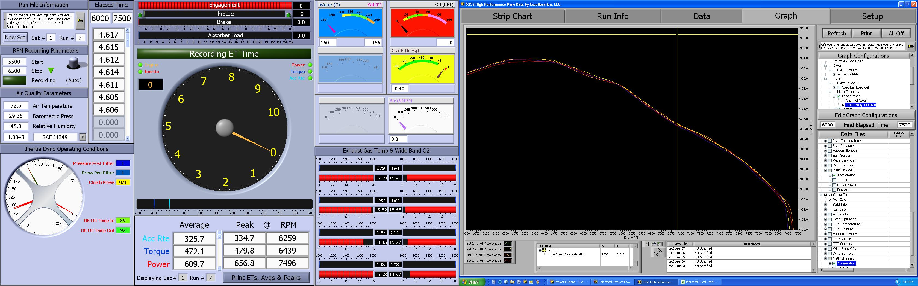

Dynamometer Specifications
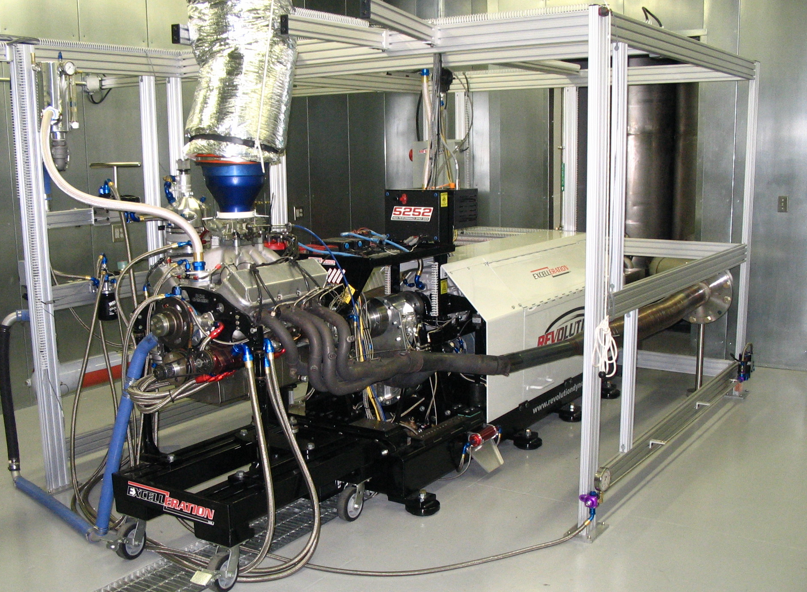
- Three Bearing Inertia Dynamometer
  - Water Absorber w/ Oiled Bearings
  - Load Control Valve with HBM Load Cell
  - Gear Transfer Case with Adjustable Ratio
  - Dynamometer Clutch Engagement System
  - Custom Starter System Adaptable to Any Brand Engine
  - Engine Tool Tray at Rear of Engine
  - Detachable Engine Docking Station or Fixed Engine Station Option

Dynamometer Cell Support
- Aluminum Support Structure Surrounding Machine
- Wire Loom Track
- Brackets and Supports for Mounting Heat Exchangers, Water Surge Tanks, Oil Tanks
- Dynamometer Water Surge Tank for Discharging Water from Heat Exchangers and Absorber
- MagnaFuel 12 VDC Fuel Pump with Filter Cartridge and Regulator

Data Acquisition System
- 5252 High Performance Dyno Data System
  - Dual Monitor Operating Station
  - Dedicated Computer System w/ Surge Protection, Printer
  - Dedicated Data Acquisition Tower for Electronics
  - Automated Throttle System Following Defined Throttle Trace
  - Complete Lap Simulation Using Inertia and Absorber Combined

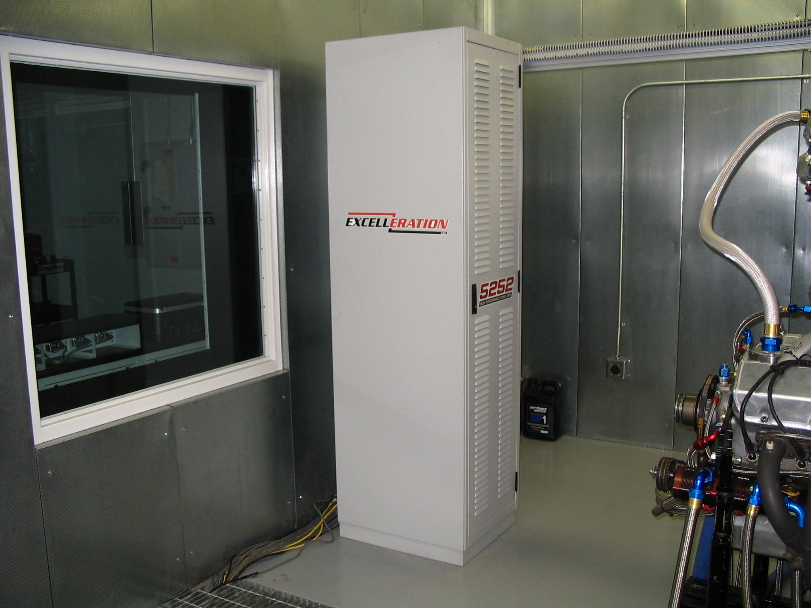
Data Acquisition System (continued)
- Extensive Sensor Package
  - Pressure Sensor Panel with Positive Pressure Sensors & Vacuum Sensors
  - RTD Temperature Sensors
  - Engine RPM & Inertia RPM Sensor System
  - Fuel, Water, and Oil Flowmeters
  - Throttle Position Sensor
  - HBM Load Cell on Absorber
  - Air Turbine Flowmeter

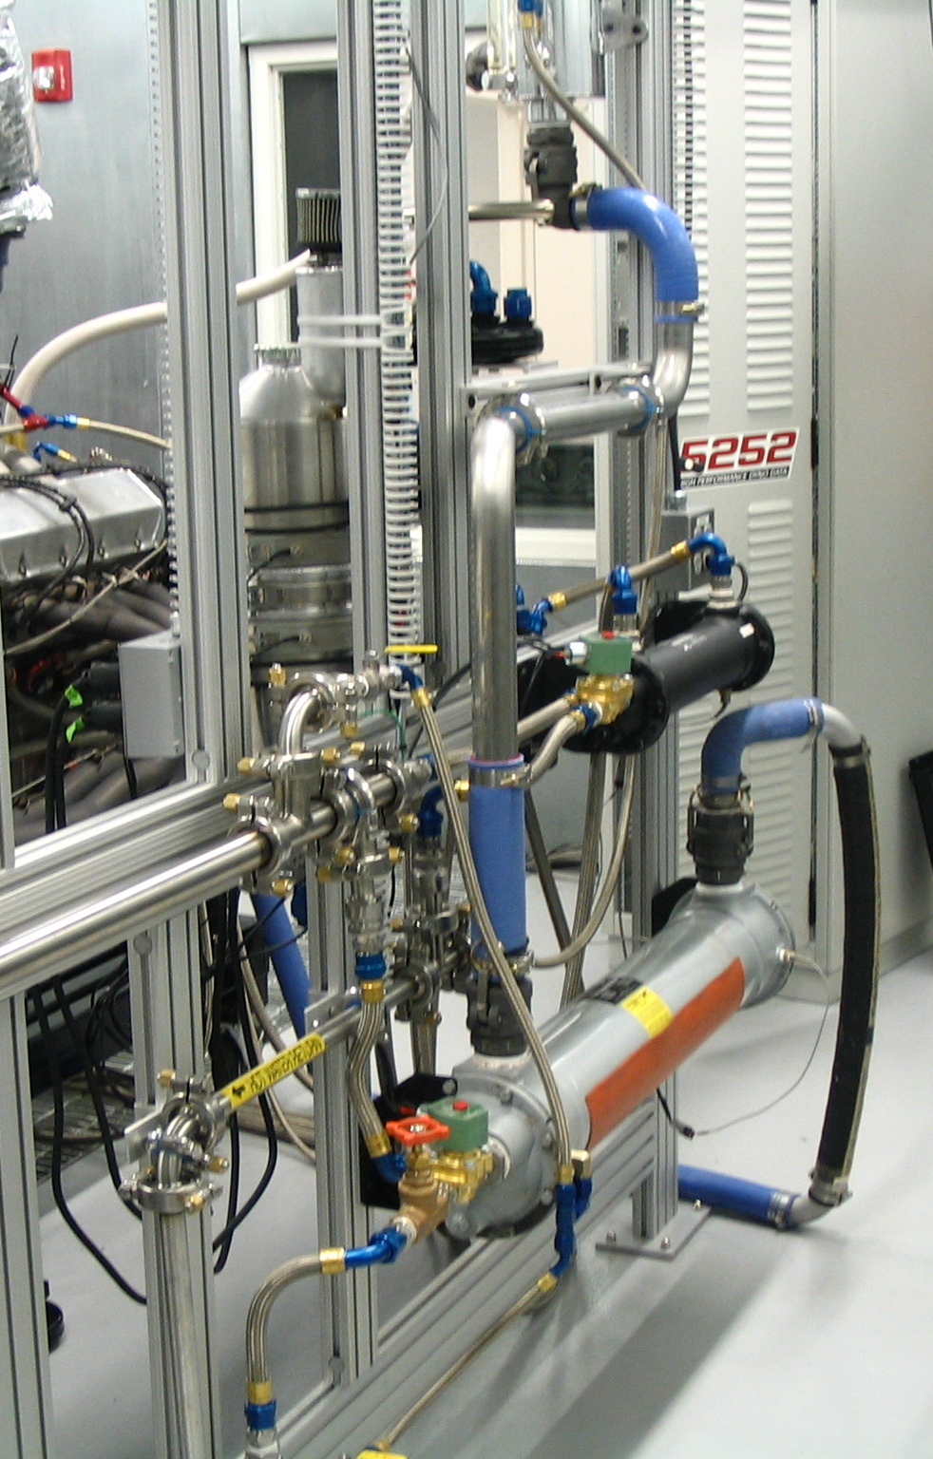
Plumbing System
- Remote Dynamometer Lubrication System w/ Filtration and Cooling System
  - 2 Gallon Reservoir on Machine
  - 20 Gallon Remote Supply Tank
- Stainless Steel Sanitary Grade Water Plumbing for Water Supply/Return

Electrical System
- AC to DC Conditioned Ignition Power Source
- Dedicated Electro-mechanical Dynamometer Control System
- 12VDC Starter Battery and High Frequency Charger

Dyno Cell Controls
- Heat Exchangers
  - Engine Water Heat Exchanger with Electrical Automated Temperature Control
  - Engine Oil Heat Exchanger with Electrical Automated Temperature Control
- Engine Heater Control System
  - Electrically Operated Heater Control System for Engine Oil and Engine Water

Service and Maintenance
- Service and Maintenance Contract Available

